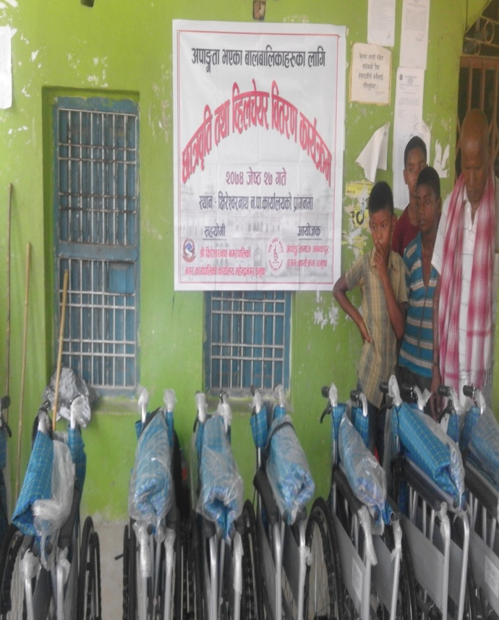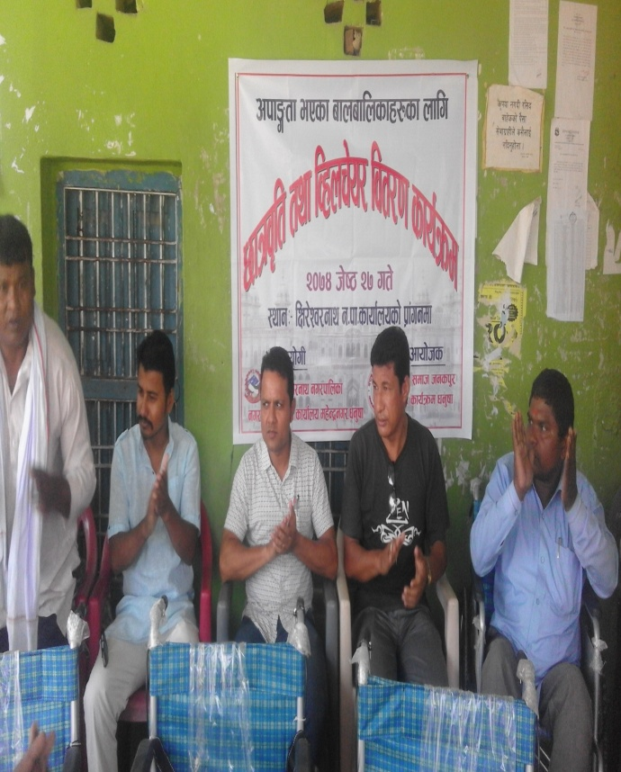
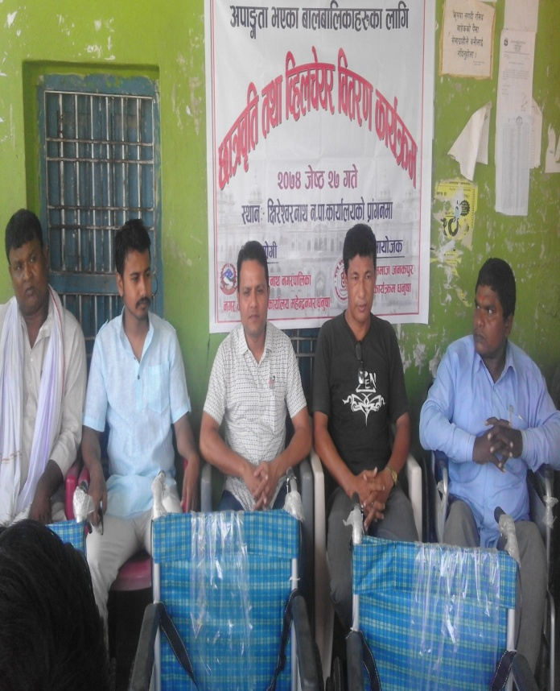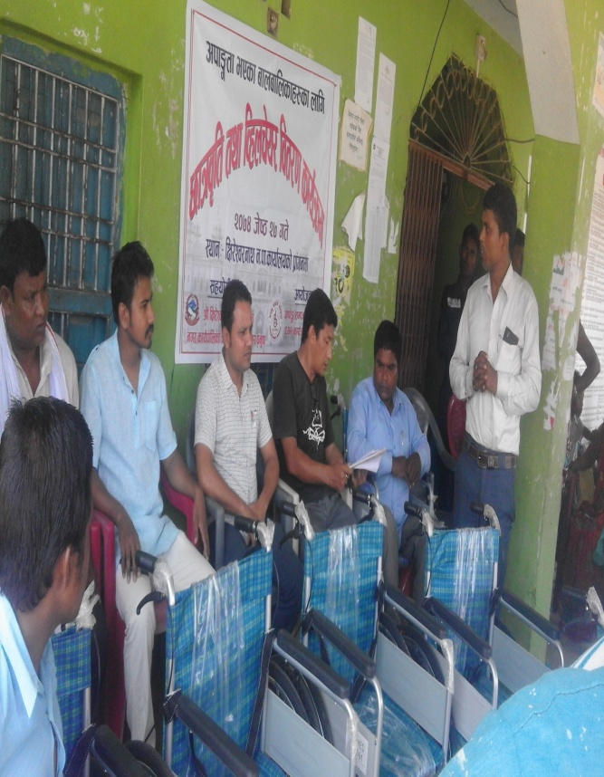
lIf/]Zj/gfy gu/kflnsf gu/sfo{kflnsfsf] sfof{no dx]Gb|gu/,wg'iffdf ckf·tf ePsf afnaflnsfx/nfO{ 5fqj[lt tyf lJxnr]o/ ljt/0f sfo{qmdsf] emnsx?

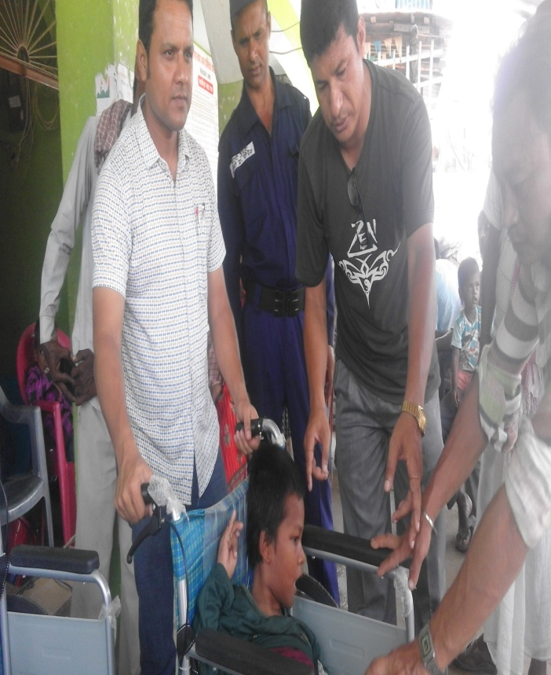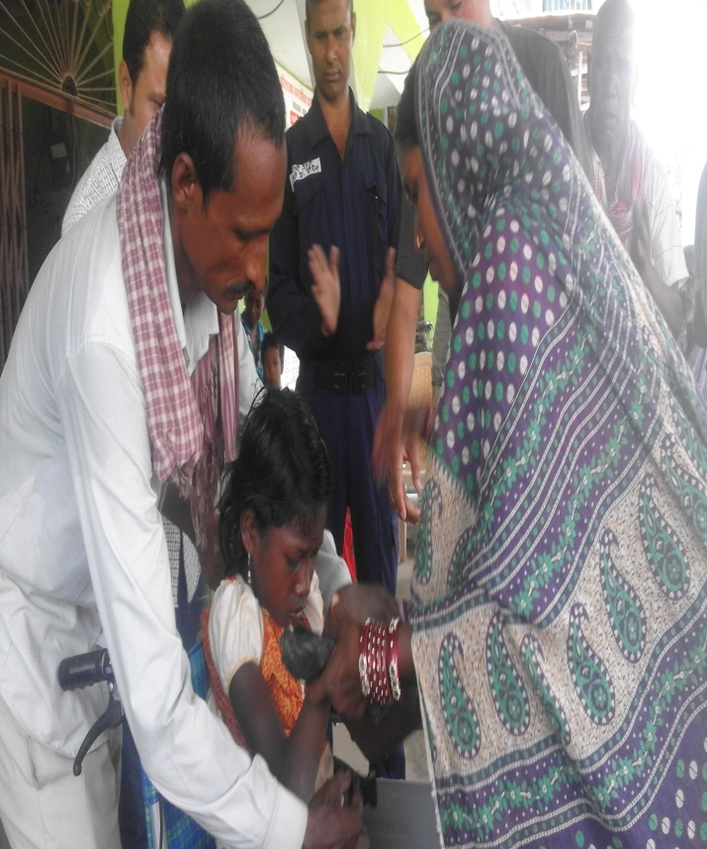
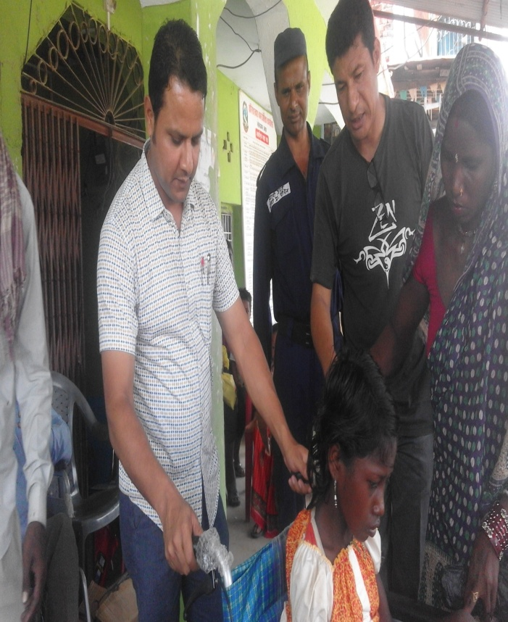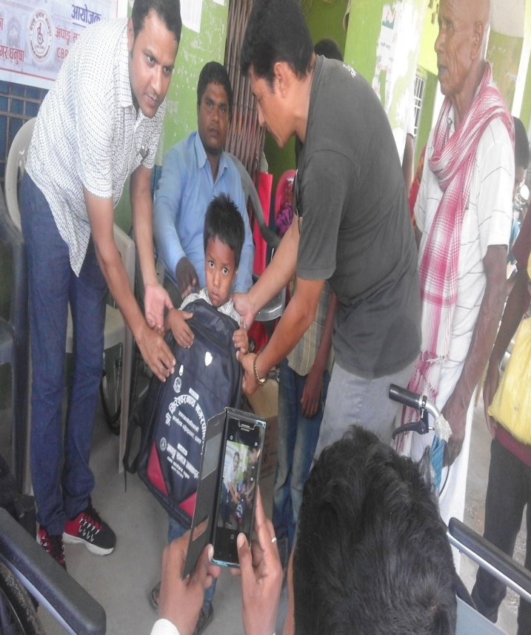
lIf/]Zj/gfy gu/kflnsf gu/sfo{kflnsfsf] sfof{no dx]Gb|gu/,wg'iffdf ckf·tf ePsf afnaflnsfx/nfO{ 5fqj[lt tyf lJxnr]o/ ljt/0f sfo{qmdsf] emnsx?
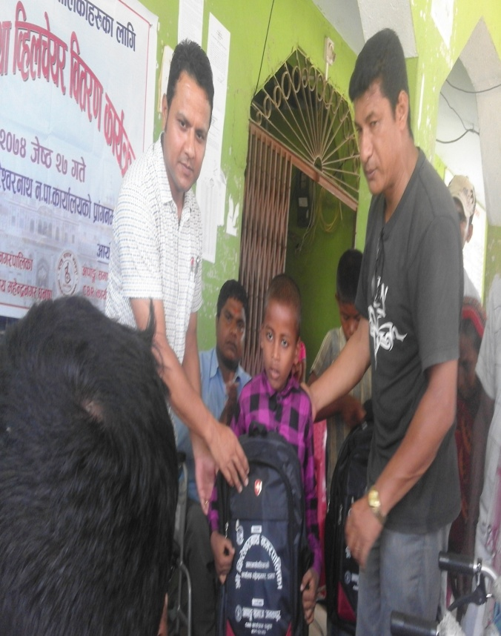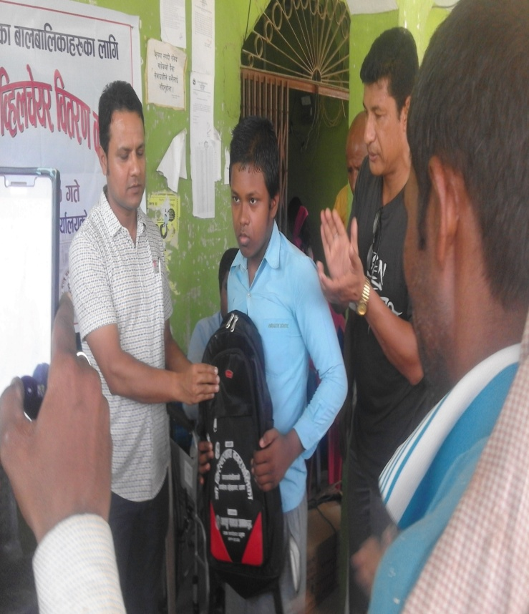
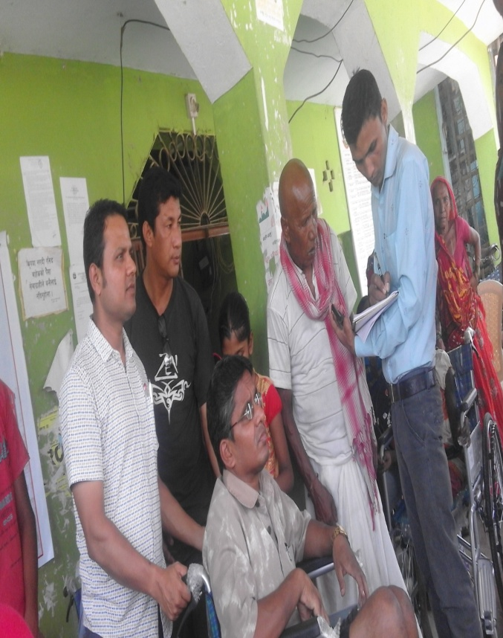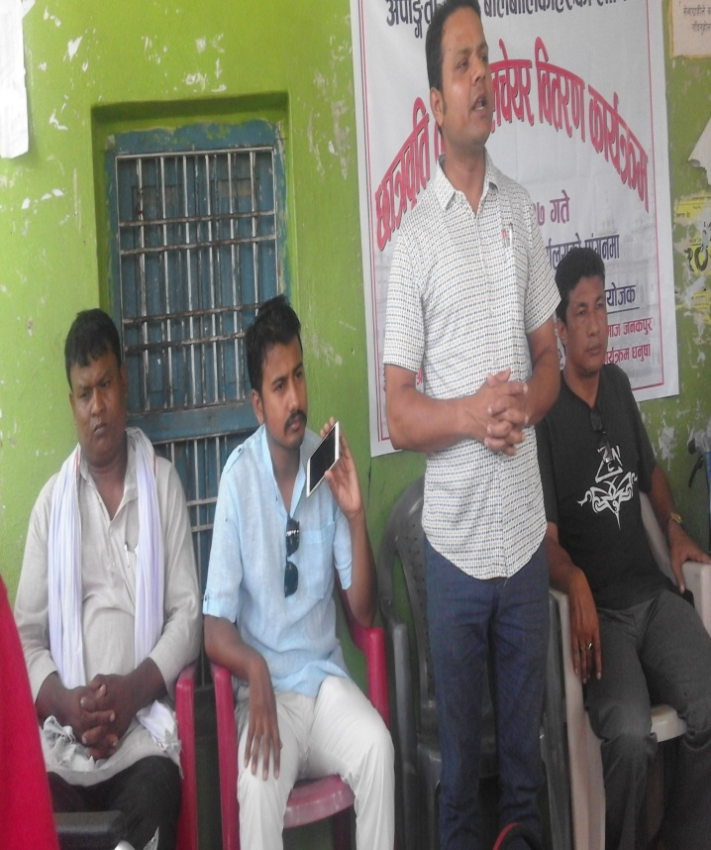
lIf/]Zj/gfy gu/kflnsf gu/sfo{kflnsfsf] sfof{no dx]Gb|gu/,wg'iffdf ckf·tf ePsf afnaflnsfx/nfO{ 5fqj[lt tyf lJxnr]o/ ljt/0f sfo{qmdsf] emnsx?

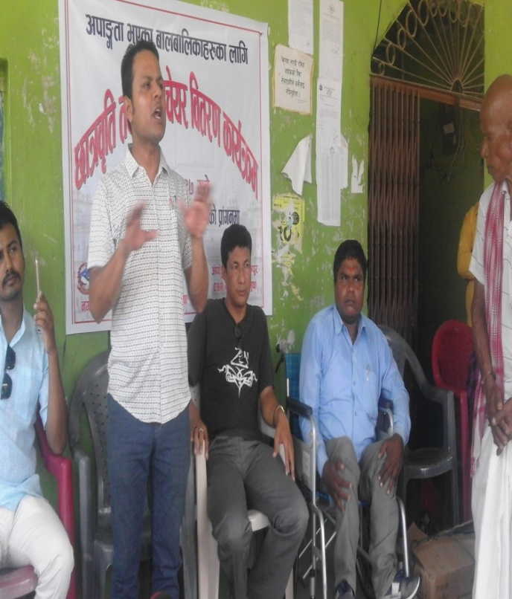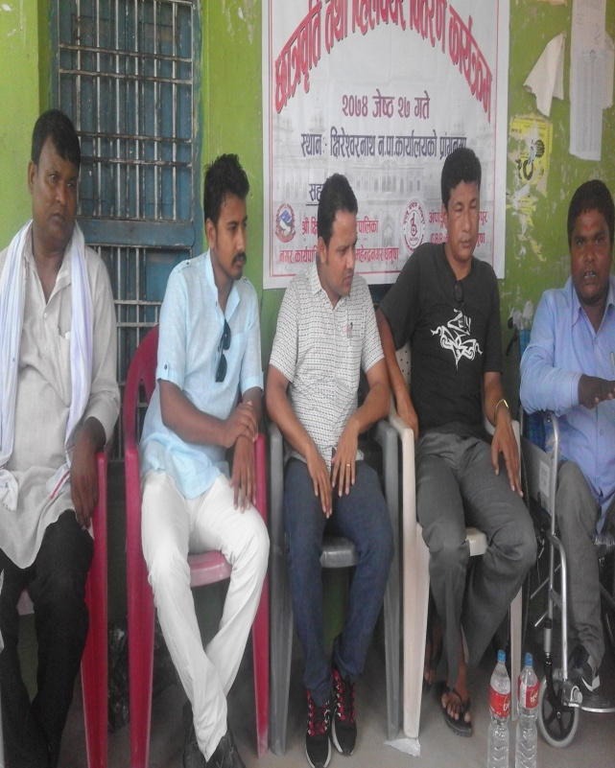
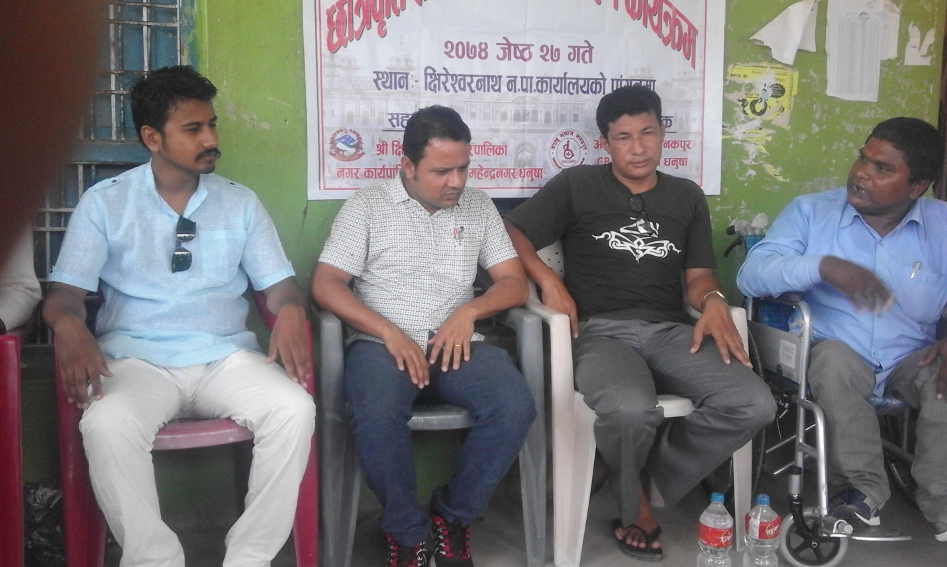
lIf/]Zj/gfy gu/kflnsf gu/sfo{kflnsfsf] sfof{no dx]Gb|gu/,wg'iffdf ckf·tf ePsf afnaflnsfx/nfO{ 5fqj[lt tyf lJxnr]o/ ljt/0f sfo{qmdsf] emnsx?

